PreLab 05 – Worksheet

Name: Mohammad Husain Naqvi (11062)  Syed Fakhar Iqbal Rizvi | ID: 11062  11091 | Section: T-4

Note: Assumptions and logics should be explained separately in tasks after the task results.

Task 1
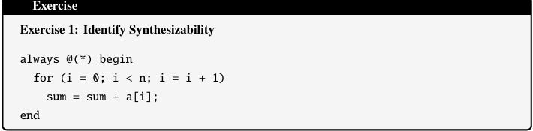

No, the above code is not synthesizable due to the following reasons:
1. ‘sum’ not being initialized in the loop.
2. The variable n is also not provided with any value or constant.

Corrected code:

parameter n = 4;
integer i;

always @(*) begin
sum = 0; // Initialize to prevent latch inference
for (i = 0; i < n; i = i + 1) begin
sum = sum + a[i];
end
end

Task 2
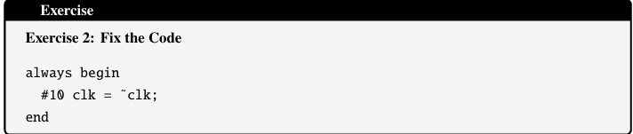

Fixed Code:

initial begin
clk = 0; // Initialize to define the starting state
end

always begin
#10 clk = ~clk; // Period = 20 time units (50 MHz if 1 ns timescale)
end

Task 3

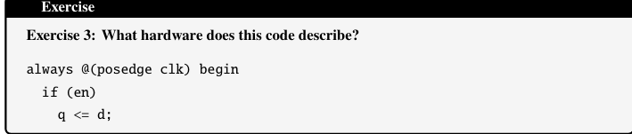

This code basically describes a positive edge triggered D flip flop. With an enable variable ‘ en ‘.

q and d have a non-blocking assignment between them.

- When en = 1 and clock is on positive edge. q will get the value of d.
- When en = 0 and clock is on positive edge. q will not get the value of d and remain in their current state.

